**Ex.No. : 03 Date:03.02.2025**

**RegisterNo.:221701004 Name:Adhithya A**

AndroidGraphicalprimitives

# Aim

Developanandroidapplicationtodrawthecircle,ellipse,rectangleandsometext using Android Graphicalprimitives

## Procedure:

**Step1:**File->NewProject

ProvidetheapplicationnameandClick“Next”

**Step2:**Selectthetargetandroiddevices

SelecttheminimumSDKtoruntheapplication.Click“Next”.

**Step3:**Choosetheactivityfortheapplication(Bydefaultchoose“BlankActivity).

Click “Next”.

**Step4:**Enteractivitynameandclick&quot;Finish&quot;.

**Step5:**Edittheprogram.

**Step 6:** Runtheapplication,2-waystorunthe application.

1. Runningthroughemulator
2. Runningthroughmobiledevice

**DepartmentofComputerScienceandDesign**| **RajalakshmiEngineeringCollege**

.

1

## AndroidManifest.xml

<?xmlversion="1.0"encoding="utf-8"?>

<manifest xmlns:android="<http://schemas.android.com/apk/res/android>"package="com.example.ex3">

<applicationandroid:allowBackup="true" android:label="DrawingApp" android:icon="@mipmap/ic_launcher"

android:roundIcon="@mipmap/ic_launcher_round" android:supportsRtl="true" android:theme="@style/Theme.Ex3">

<activity android:name=".MainActivity" android:exported="true">

<intent-filter>

<actionandroid:name="android.intent.action.MAIN"/>

<categoryandroid:name="android.intent.category.LAUNCHER"/>

</intent-filter>

</activity>

</application>

</manifest>

## Activity_main.xml

<?xmlversion="1.0"encoding="utf-8"?>

<LinearLayout

xmlns:android=["http://sche](http://sche/) mas.android.com/apk/res/a ndroid"

android:orientation="vertical"

android:layout_width="match_parent"

2

**DepartmentofComputerScienceandDesign**| **RajalakshmiEngineeringCollege**

.

android:layout_height="match_parent">

<com.example.ex3.CustomDrawingView

android:id="@+id/customVi ew"

android:layout_width="match_parent"

android:layout_height="ma tch_parent"/>

</LinearLayout>

## MainActivity.kt

packagecom.example.ex3

import android.os.Bundle import androidx.appcompat.app.AppCompatActivity

class MainActivity : AppCompatActivity() {

override fun onCreate(savedInstanceSta te: Bundle?) {

**DepartmentofComputerScienceandDesign**| **RajalakshmiEngineeringCollege**

.

3

super.onCreate(savedInstanceState)

setContentView(R.layout.*a ctivity_main*)

}

}

# CustomDrawingView

package com.example.ex3

import android.content.Context import android.graphics.Canvas import android.graphics.Color import android.graphics.Paint import android.graphics.RectF import android.util.AttributeSet import android.view.View

class CustomDrawingView(context: Context, attrs:

4

**DepartmentofComputerScienceandDesign**| **RajalakshmiEngineeringCollege**

.

AttributeSet?) : View(context,attrs){

privatevalpaint= Paint()

override fun onDraw(canvas: Canvas)

{

super.onDraw(canvas)

true

// Smooth edges paint.*isAntiAlias* =

//1.DrawCircle paint.*color* =

Color.*RED*

paint.*style*= Paint.Style.*FILL*

canvas.drawCircle(300f, 300f, 100f, paint)

//2.DrawEllipse paint.*color* =

Color.*BLUE*

val oval = RectF(500f, 100f, 800f,

**DepartmentofComputerScienceandDesign**| **RajalakshmiEngineeringCollege**

.

5

300f)

canvas.drawOval(oval,paint)

//3.DrawRectangle paint.*color* =

Color.*GREEN*

canvas.drawRect(100f, 500f,500f,700f,paint)

//4.DrawText paint.*color* =

Color.*BLACK*

paint.*textSize*=60f

canvas.drawText("Hellofrom Canvas!", 100f, 850f, paint)

}

}

6

**DepartmentofComputerScienceandDesign**| **RajalakshmiEngineeringCollege**

.

***Output:***

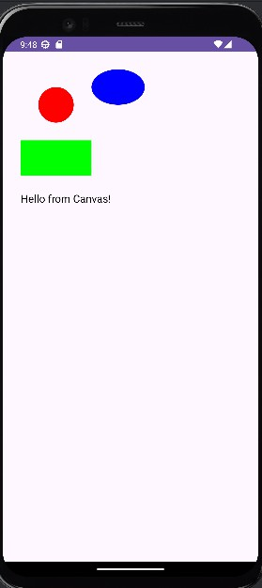

# Result:

TheApplicationwasdevelopedusing KotlininAndroidStudio.

**DepartmentofComputerScienceandDesign**| **RajalakshmiEngineeringCollege**

.

7